

Title: Three-Year Enrolment and Financial Projections
To: Finance, Budget and Enrolment Committee
Date: 24 January 2018
Report No.: 01-18-3306

Strategic Directions
- Make every school an effective school; and
- Form strong and effective relationships and partnerships.

Recommendation
It is recommended that the report regarding the Three-Year Enrolment and Financial Projections be received.

Context
Appendix A contains the actual and projected pupils of the Board for the years 2016-2021. The Planning Department has included in Appendix A additional information to support the enrolment projections. This includes information on birth rates, three year-old population, immigration trends and historical enrolment trend information.
In 2018-2019, Planning is currently projecting an increase in Elementary of approximately 414 students and a small decline in Secondary of approximately 238 students.
Based on these projections, the Budget Department has prepared a Three-Year Forecast of the financial position of the Board. This projection is based on the following information and assumptions:
- The grant projections are based on the current government funding model and announced funding changes in Full-Day Kindergarten (approximately $1.8M) and Grades 4 to 8 (approximately $4.2M) class size funding. This modelling does not include any changes to collective agreements in either funding or costs. It is assumed that the Ministry of Education will fund any changes to collective agreements as they are ratified. The reduction of $2.5M for benefit benchmark relates to the phase out of retirement gratuities over the remaining services life of the qualifying staff.
- Classroom teachers and other school-based staff have been adjusted for changes in enrolment each year, while all other staff are being maintained at 2017-2018 levels.
- Any increase in utility or transportation costs will be offset by grant increases. In previous years the Ministry has provided these funding allocations to adjust for inflation in costs.
- Department expenditure budgets have been maintained at 2017-2018 budget levels for all years.
- As benefit plans of various bargaining units currently operated by the Board transition to the Employee Life and Health Trusts (ELHT), it is assumed that all costs of this transition will be funded by the Ministry. This includes the cost of “orphaned” plans as they wind-up.

Action Plan and Associated Timeline
Staff will bring forward a formal Board report for approval of the budget, following consultation in the March round of meetings.

Resource Implications

The 2018-2019 budget will be balanced with the use of one-time funding sources. The first source is the anticipated retirement of a sinking fund debt, which earned excess interest in the amount of approximately $1.4M. It is anticipated that accruals in the amount of $5M provided for in previous years will no longer be required and those funds can be released to be used for operational needs. The Board’s working fund surplus is currently forecasted to be $10.9M and is available to balance the 2018-2019 budget.
As part of the 2019-2020 budget process, additional savings and program modifications of approximately $10.4M will be required. These changes will be informed by the Board’s recommendation in response to the Enhancing Equity Report and the Long-Term Strategic Plan.

Communications Considerations
This report will be posted under the 2017-2018 budget page website and the appendices will form part of the ward consultation document.

Board Policy and Procedure Reference(s)
Not applicable.

Appendices
- Appendix A: Projected Three-Year Enrolment
- Appendix B: Projected Three-Year Financial Position

From
Craig Snider, Executive Officer, Finance at craig.snider@tdsb.on.ca or at 416-395-8469.
Steve Shaw, Executive Officer, Facility Services, Sustainability and Planning at steve.shaw@tdsb.on.ca or at 416-393-8780.
Andrew Gowdy, System Planning Officer, Strategy and Planning at andrew.gowdy@tdsb.on.ca or at 416-394-3917.

Routing
Finance, Budget and Enrolment Committee 24 January 2018
Board of Trustees 7 February 2018

Appendix A
Projected Pupils of the Board Enrolment
 | Actual | Projected
 | 2016-2017 | 2017-2018 | 2018-2019 | 2019-2020 | 2020-2021
JK/SK | 35,431.0 | 35,402.4 | 34,760.4 | 34,698.4 | 34,683.4
Grades 1 to 3 | 53,401.9 | 53,164.5 | 53,295.5 | 52,958.5 | 52,717.5
Grades 4 to 8 | 82,625.6 | 84,152.2 | 85,077.2 | 85,987.2 | 86,214.2
Total Elementary | 171,458.5 | 172,719.1 | 173,133.1 | 173,644.1 | 173,615.1
Secondary | 70,540.5 | 70,164.4 | 69,926.4 | 70,600.3 | 71,111.2
Total Day School | 241,999.0 | 242,883.5 | 243,059.5 | 244,244.4 | 244,726.3
Net Change Year over Year Enrolment Analysis
 | 17-18 vs 16-17 | 18-19 vs 17-18 | 19-20 vs 18-19 | 20-21 vs 19-20
JK/SK | -28.6 | -642.0 | -62.0 | -15.0
Grades 1 to 3 | -283.0 | 131.0 | -337.0 | -241.0
Grades 4 to 8 | 1,526.6 | 925.0 | 910.0 | 227.0
Total Elementary | 1,260.6 | 414.0 | 511.0 | -29.0
Secondary | -376.1 | -238.1 | 673.9 | 510.9
Total Day School | 884.5 | 175.9 | 1,184.9 | 481.9
Enrolment projections are updated annually to support short and long-term capital planning, budget planning and Ministry reporting. The table above outlines the projected Average Daily Enrolment (ADE) of Pupils of the Board for 2017-2018 to 2020-2021. ADE is a measure of enrolment that the Ministry uses to allocate funding. Full-time equivalent (FTE) enrolment is counted twice during the school year, on the last day of October and March. The average of these two counts is the ADE. “Pupils of the Board” are defined as all pupils that are eligible for Ministry funding. Fee-paying students are not included in the above totals.
The net change in ADE enrolment for next school year (2018-2019) is projected to increase by approximately 176 students.
Elementary Enrolment Projections:
Elementary ADE enrolment is projected to increase by 414 and 511 over the next two years followed by a slight enrolment decrease of 29 in 2020.
Elementary projections at the front end (incoming JK enrolment) are influenced by live births and the three year-old preschool population. Live births have remained fairly stable over the past three years (2014-2016), resulting in stable projections for the three year-old population group between 2017-2019. Over the past two years, the TDSB has retained a consistent share of approximately 64% of the previous year’s three year-old population cohort. This trend is anticipated to continue, resulting in a stable incoming JK projection of approximately 17,000 for 2018–2020.
Elementary enrolment is also influenced by the size of the outgoing grade 8 cohort. Enrolment is projected to increase marginally over the next two years in part due to smaller graduating Grade 8 cohorts being replaced by larger incoming JK enrolments. A slight enrolment decrease of 29 is projected in 2020, due in part to a larger graduating grade 8 cohort and a stable incoming JK population.
City of Toronto Live Births: 1990-2016
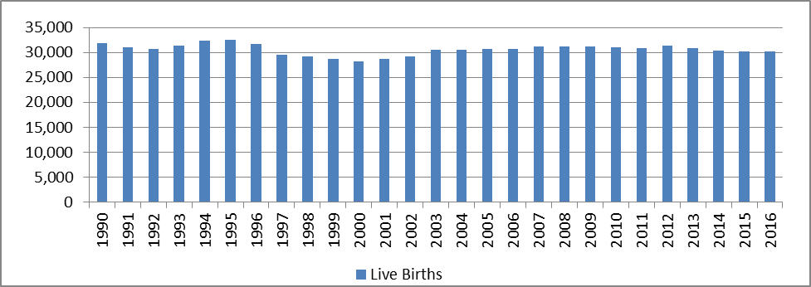
Source: Baragar Systems/Ontario Birth Registry, January 2018

City of Toronto Three Year-Old Preschool Population: 1990-2019
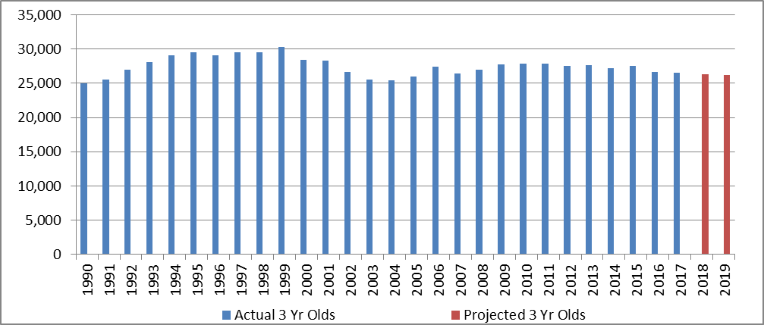Source: Baragar Population Projections, Preliminary 3-Year Old update, November 2017
Grade 8 Enrolment
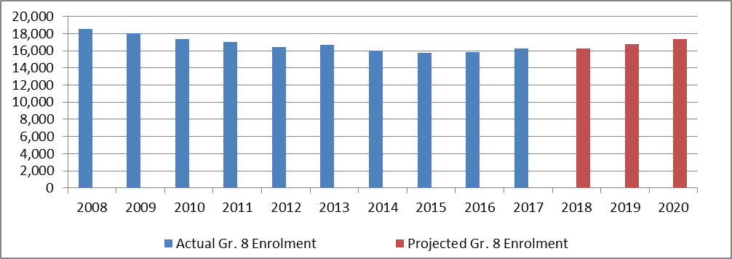
Retention throughout the grades (SK–Grade 8) is another indicator used in calculating enrolment projections. Historical trends are analyzed to provide insight for future trends. The relationship between the number of students in a grade and the number of students that move on to the next grade in the following year is observed to determine the retention rate. In the past two years, there has been a notable increase in elementary retention rates throughout the grades, driven in part by an increase in “new entrants”, defined as students actively attending in the current year but not present in the previous year, and fewer “exits”, defined as students active in the previous year that are no longer present in the following year.
Newcomer students arriving to the TDSB from non-English speaking countries have had a positive influence on retention rates over the past two years. In 2016, total ESL elementary enrolment increased by 1,243 over the previous year to 15,052. This includes approximately 700 Syrian newcomer students. In 2017, ESL enrolment increased by another 918 students to 15,970. These increases were driven by a change in Federal immigration targets, as evidenced in the table below.
Federal Immigration Targets - All Categories
 | Actual Number of Permanent Residents Admitted |  |  |  |  |  |  | Projected Target
 | 2010 | 2011 | 2012 | 2013 | 2014 | 2015 | 2016 | 2017 | 2018 | 2019 | 2020
Total Admission Targets | 280,687 | 248,747 | 257,903 | 259,023 | 260,404 | 271,845 | 296,346 | 300,000 | 310,000 | 330,000 | 340,000
Source: 2010-2016: Annual Reports to Parliament on Immigration, 2017-2020: CanadaVISA (Canada's Multi-Year Immigration Plan 2018 to 2020) https://www.canadavisa.com/canada-multi-year-immigration-plan-2018-to-2020.html
Elementary ESL Enrolment: 2004-2017
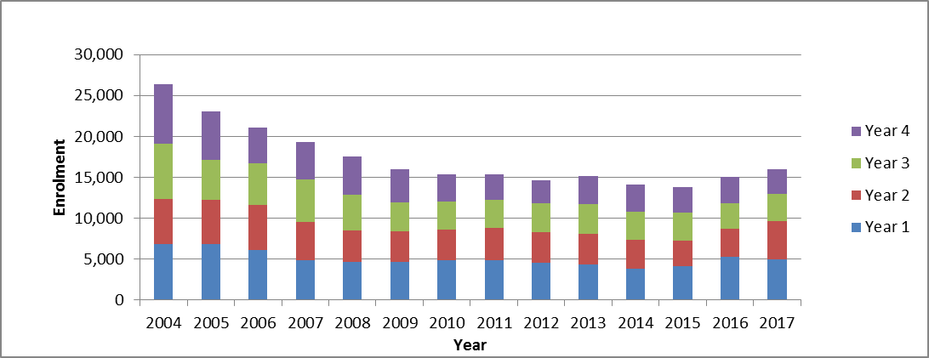
Secondary Enrolment Projections:
Secondary enrolment is projected to decline by 238 in 2018-2019, followed by increases of 674 in 2019-2020 and 511 in 2020-2021.
Secondary projections at the front end are influenced by the incoming Grade 9 cohort. Smaller graduating grade 8 classes are continuing to work their way through the elementary panel into the secondary panel, partially contributing to declining secondary enrolments over the past seven years. Larger graduating Grade 8 cohorts are projected to enter the secondary panel beginning in 2020-2021. Grade 9 enrolments are also influenced by the number of new students entering the TDSB (new entrants) compared with those exiting the TDSB after Grade 8 (exits). Over the past two years, on average the TDSB has attracted 1,911 new entrants in Grade 9 (12.1% of total Grade 9 enrolment), compared with an average exit population of 1,723 (10.7% of previous year Grade 8 enrolment). By comparison, in 2014, there were 1,748 new entrants in Grade 9 (10.7% of total Grade 9 enrolment) compared with an exit population of 1,882 (11.3% of previous year Grade 8 enrolment).
Secondary enrolment projections are also influenced by graduation rates. As indicated by the graphs and tables below, since 2006, the number of students returning to the TDSB for a 5th year has decreased annually, while the number of students leaving the TDSB after Year 4 has increased annually. This has resulted in lower enrolment totals for the 18-21+ age groups over this time frame. These trends are expected to continue over the next three years.
Proportion of Year 4 (Grade 12) Students Returning to and Leaving the TDSB (2006-07 - 2014-15)
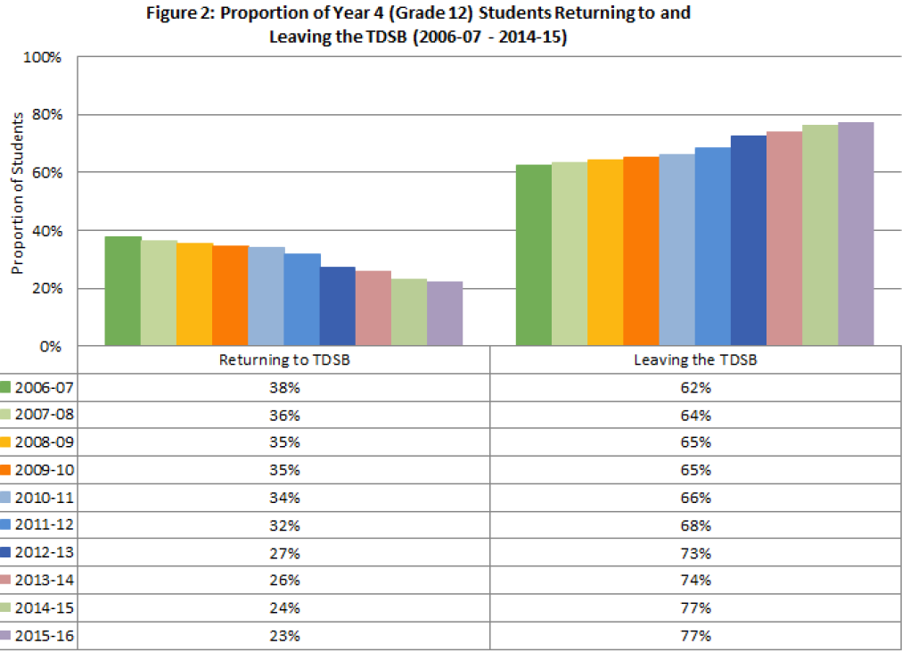
Source: TDSB Research Department, Secondary Success Indicators, June 2017
Retention throughout the age groups (15–21+) is another indicator used in calculating secondary enrolment projections. The relationship between the number of students in an age group and the number of students that move on to the next age group in the following year is observed to determine the retention rate. Similar to the elementary panel, in the past two years, there has been a notable increase in secondary retention rates throughout the grades, driven in part by an increase in new entrants and fewer exits. Newcomer students arriving to the TDSB from non-English speaking countries have had a positive influence on secondary retention rates over the past two years. In 2016, total ESL secondary enrolment increased by 262 over the previous year to 6,980. In 2017, ESL enrolment increased by an additional 343 students to 7,323.
Secondary ESL Enrolment: 2004-2017
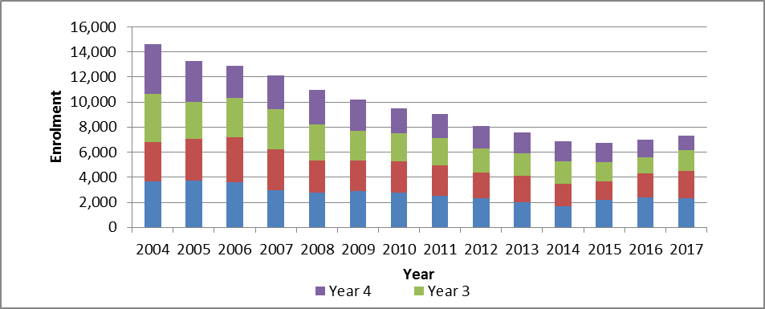
System Enrolment Projections:
As a system, TDSB enrolment is projected to increase in 2018-19 by 175.9, followed by an increase of 1,184.9 in 2019-20 and an increase of 481.9 in 2020-21.

Appendix B

